Date
To:
Re: X Yr

Dear
You may be aware, [name] has struggled with their gender identity for quite some time. They have been quite anxious and distressed at times over the [timeframe]. As they are getting older however, they have been finding it more and more difficult. They have been extremely uncomfortable with their body and being [sex assigned at birth] for some time now, and this has impacted them through [detail as appropriate such as anxiety, sleep problems etc]
They have expressed their preference to be identified as [enter gender identity] and to start a formal, social transition.
Their preferred name is X and preferred pronouns are he/him / she/her they/them [update as appropriate]
[Chosen name] came to this decision after months of guidance and counselling from parents and professionals and has been able to maturely express their wishes and how to manage this transition in a number of ways.
So, for X’ s school life we would like to discuss the following and see if it can be put in place for the beginning of their new term.
I’ve had a look at School website and I am unsure about your transgender policy and training, so I apologise if you are up to speed already with these issues.
The pdf called Trans inclusion School Kit – issued by Brighton and Hove Council, is recommended to share with Schools. I have copied the following for us to discuss to support X in [his/her/their] social transition at school. https://uploads-ssl.webflow.com/5888a640d61795123f8192db/5bb6216a5253bf4eea4ebeb9_Trans_Inclusion_Schools_Toolkit_Version_3.2_2018.pdf 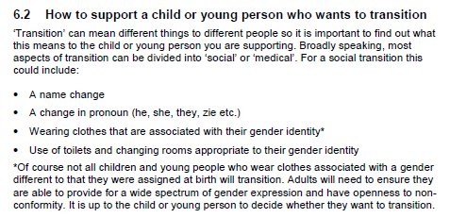

So, if we can address these points for school – that would be amazing
- Name [X surname], I know that some trans students in other schools have had the name change on the register and other systems to preferred name, and that can be done on SIMS as well
- Pronoun [x] – this probably doesn’t come up when you are directly talking to X but about [him/her/them] to other people
- Wearing clothes, X would really like to wear [detail uniform requirements]
- Sports – X would like to carry on playing [detail any sports requirements]
- Toilets and changing room – would you be able to assign an accessible toilet or changing room in each block? [update/amend as appropriate depending on request]
Regarding pastoral care and emotional support, it would be helpful to discuss how and when X could go to someone for support and what procedures could be put in place so that X is confident of what to do in certain circumstances.
We really appreciate the support that the school can provide at this time. Small changes such as the name change, pronouns, the more people close to X that know have made a huge difference in their happiness and it would be so beneficial if this could be carried on into school life where [he/she/they] will now spend so much time.
Myself and X are available this week to discuss further if that would be helpful.
Very best wishes

