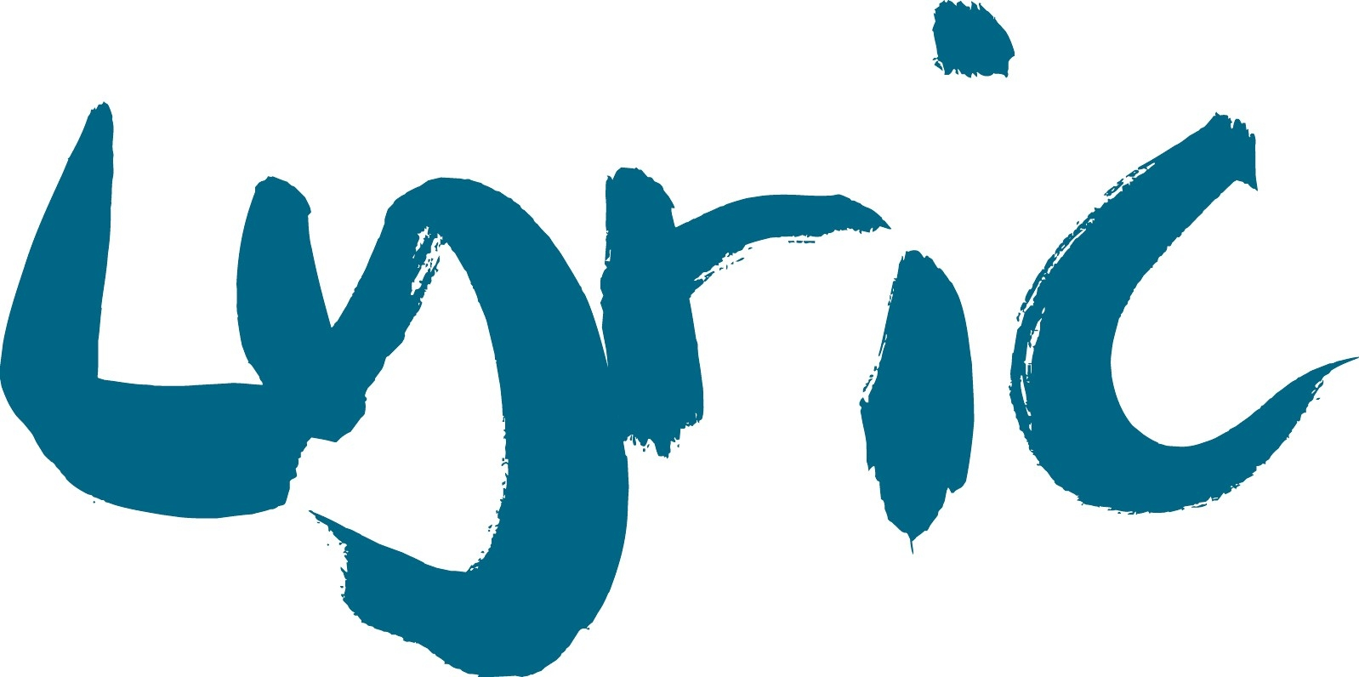

Young Lyric Bursary Fund Application Form

The Lyric Hammersmith Theatre is delighted to offer one bursary placement for each Young Lyric class. Please complete the application form below to apply.

To be eligible the young person must:
- Be signed up as a Young Lyric Member - you can do so here
- Live in one of the 10 West London boroughs (Brent, Ealing, Hammersmith and Fulham, Harrow, Hillingdon, Hounslow, Kensington and Chelsea, Richmond upon Thames, Wandsworth or Westminster)
- Be aged between 0-25
- Receive free school meals or universal credit (age dependent)
- Apply for a class that is not free of charge and doesn’t require audition to access

Please note this bursary will be one term of activity. The discretion of a bursary placement is solely that of the Lyric Hammersmith Theatre, who will work in collaboration with activity partners and providers to issue.
Name:
Address (including borough and postcode):
Email:
Phone Number:
Date of Birth:
Current School and Borough (if in education);
Which class would you like to join?
Are you currently a Young Lyric Member?

Please tell us why you need to supported by the bursary fund (please state if you receive free school meals or universal credit here).

What activity (if any) have you done before at the Lyric or with our partners? Did you receive a bursary for this?

How did you hear about the Young Lyric bursary fund?

Please email this form to learning@lyric.co.uk

The information contained in this form will only ever be used for purposes of equal opportunities monitoring and will be stored securely at the Lyric Hammersmith Theatre. We will only pass your information on to other agencies when we believe it is lawful in accordance with the Data Protection Act 1998 and when it is appropriate to do so.
If you have any questions about filling out this form please contact us at learning@lyric.co.uk

