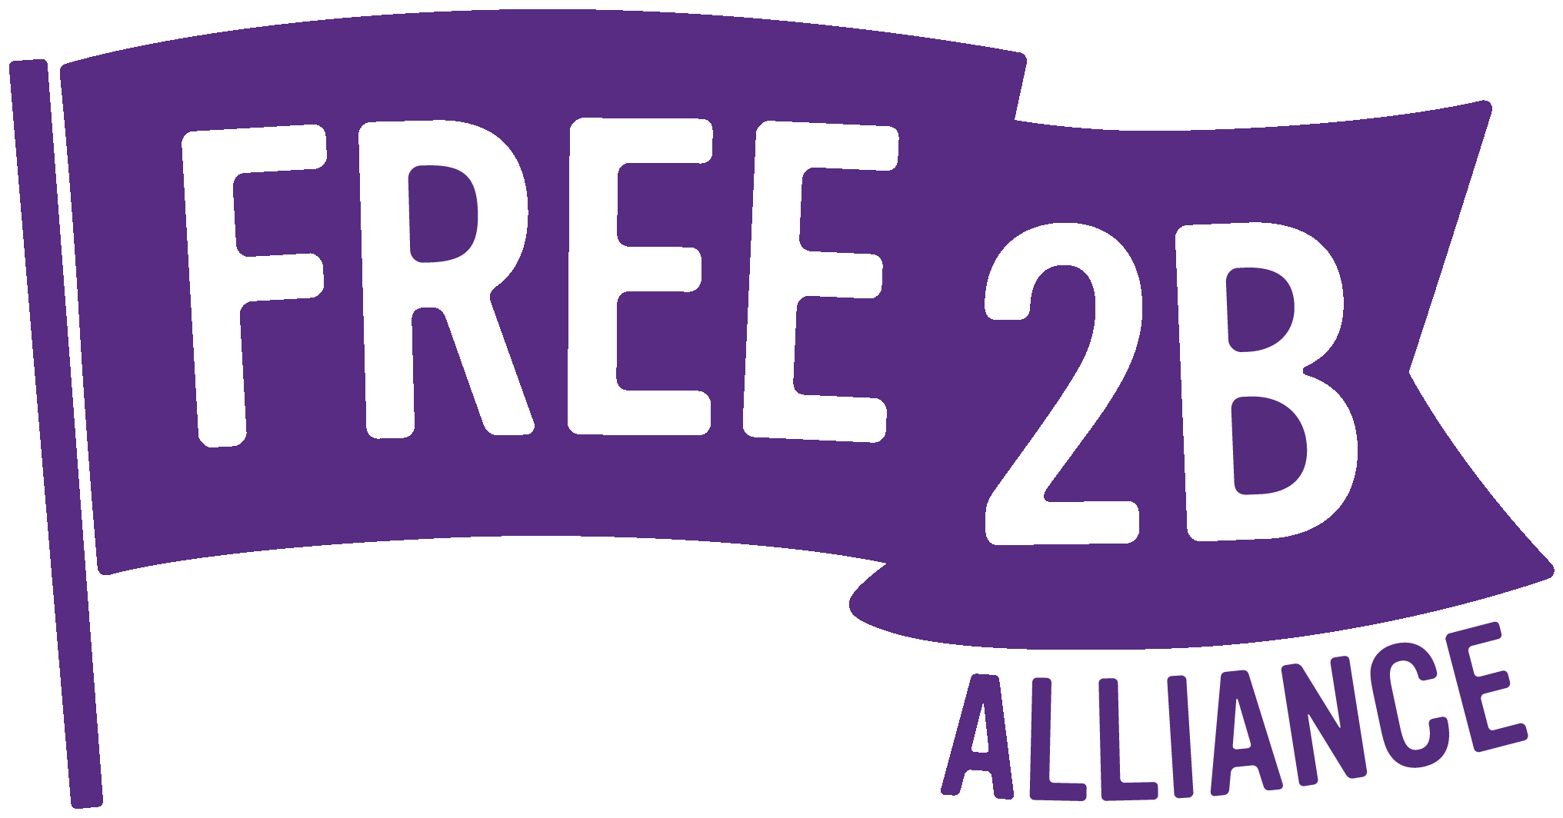

**Job Application Pack**

**Gap Lead Youth Worker**

Included in this pack:

* Organisation information
* Job Description
* Personal specification

**Rolling recruitment process**

**Applications will be reviewed as they are received, and suitable candidates will be invited for an in-person interview.**

**Please return completed applications to** [**hello@free2b.lgbt**](mailto:hello@free2b.lgbt)

**Further Information**

If you’d like to talk about this position in more detail, then please contact:

Georgina Wilkinson: Youth Service Manager | [georgina@free2b.lgbt](mailto:georgina@free2b.lgbt) | 07529 221 239

Lucie Brooke: Principal Lead | [lucie@free2b.lgbt](mailto:lucie@free2b.lgbt) | 07757 502 726

**Gap LGBTQ+ Youth Club -**

**Lead Youth Worker**

**Job Description**

Job Title: Lead Youth Worker

Position: Fixed Term contract to Dec 2026

Salary: **£16.31 per hour**

Hours: **4 hours per week including 2-hour club session every Friday evening 6-8pm.**

Plus, adhoc additional hours as agreed to cover occasional trips, events, residentials etc.

Holidays: 22.4 hours per year (including bank holidays)

Responsible to: Youth Service Manager

Location: Clapham Junction venue (address safeguarded) and admin tasks working from home or Clapham Junction venue as preferred

**About Free2B**

Free2B Alliance is a Community Interest Company supporting the LGBTQ+ community. Free2B has three key service areas:

* Support for LGBTQ+ young people via youth groups and 1:1 targeted support
* Support for parents of LGBTQ+ children, via Proud Parents group & 1:1 mentoring.
* Delivering LGBTQ+ awareness training, to foster an inclusive environment within education establishments and organisations across the sectors.

Free2B has a small, dedicated, collaborative and creative LGBTQ+ youth service team who support over 200 young people each year through our 1:1 and group services. Our key outcome aims are:

* Improving wellbeing
* Building personal resilience
* Reducing social isolation

**OUR MISSION**

Free2B improves LGBTQ+ lives by providing responsive wellbeing support, safe spaces and proactive education, empowering local communities to address discrimination.

**OUR VALUES**

|  |  |
| --- | --- |
|  | **Listening:** Encouraging participation & actively listening to our members |
|  | **Collaborating:** Strengthening the shared voice and championing Inclusion |
|  | **Respecting:** Celebrating diversity and respecting individuals |
|  | **Educating:** Challenging discrimination without confrontation |

[www.free2b.lgbt](http://www.free2b.lgbt)

**Key Objectives for this Role**

* Deliver a safe and inclusive space for LGBTQ+ young people aged 13-19 (and up to 25 for those with complex additional needs).
* Oversee weekly operations for a comprehensive programme at Gap youth club.
* Encourage active participation.

**Roles & Responsibilities**

**Planning**

* Support the planning of the Gap youth club service with the young people themselves, partners, and funders.
* Coordinate the quarterly activity planner and rota ensuring a positive and responsive range of activities and sufficient staffing.
* Manage and respond to any last-minute rota changes or team delays in arriving.
* Plan and purchase weekly refreshments in line with allocated budget.

**Delivery**

* Lead the weekly youth club sessions, providing a safe social space for LGBTQ+ young people.
* Design, develop and deliver activities, projects, and events, underpinned by the youth service curriculum and young peoples’ feedback.
* Build relationships with young people, which enable them to explore and make sense of their experiences.
* Assist with the identification of the needs of young people.
* To be fully aware of the principles of safeguarding as they apply to young people and vulnerable adults in relation to your work role.
* Ensure a welcome induction is completed with new members.
* Ensure all relevant paperwork is completed for new members and maintain accurate attendee records.
* Address and manage any behaviour issues in line with the youth club ground rules.

**Support Volunteers**

* Provide 121 support supervision to each volunteer annually and co-deliver an annual group supervision with the volunteer team.
* Support the volunteer team to lead and or co-facilitate Gap activities sessions.

**Undertake Other Duties**

* Undertake any other appropriate tasks, as agreed with your line manager.

**Person Specification**

|  |  |
| --- | --- |
| **Skills / Experience & knowledge** | **Essential /**  **Desirable** |
| Minimum 3 years’ experience of direct youth work, ideally in an LGBTQ+ service. | **E** |
| Experience of designing and delivering activities to meet a range of needs and abilities, ideally underpinned by the youth work curriculum. | **E** |
| Knowledge & understanding of child protection and safeguarding issues, policies, and procedures. | **E** |
| Ability to initiate, build and maintain purposeful relationships with young people. | **E** |
| Ability to effectively challenge negative behaviours in groups and individuals. | **E** |
| Ability to establish and maintain appropriate professional boundaries with young people. | **E** |
| Personal attributes to include being: organised / take initiative / reliable / ability to work under pressure. | **E** |
| Experience of providing information, advice, and guidance to support volunteers in their induction and ongoing development. | **D** |
| Youth Work qualification | D |

**Further Information**

* Free2B Alliance is committed to equal opportunities.
* All offers to work at Free2B Alliance are subject to satisfactory references, which is standard Free2B policy applicable to all roles. Free2B also ask for an enhanced DBS (formerly known as CRB) check.
* You will adhere to matters of confidentiality concerning this role and the Free2B team.

**Application Process**

**Please email your CV, cover letter and** [**equal opportunities monitoring form**](https://free2b.lgbt/wp-content/uploads/2023/06/Free2B-Application.-Equal-Opportunities-Monitoring-Form.docx) **to** [**hello@free2b.lgbt**](mailto:hello@free2b.lgbt)

**Please ensure your cover letter explains how you meet each of the criteria on the personal spec. Ideally utilise the table / criteria above so that it is clear which element you are referring to.**